**BUILD A NUTRITION IMAGE ANAYLSIS DASHBAORD USING IBM**

# 1.INTRODUCTION:

# 1.1 Overview:

Nutrition plays a great role in our daily life. The food or liquids affect our body and health because each food or liquid contain particular nutrition which is very necessary for our physical and mental growth. A particular level of any particular nutrition is essential for our body.

Due to the improvement in people's standards of living, obesity rates are increasing at an alarming speed and this is reflective to the risks in people's health. People need to control their daily calorie intake by eating healthier foods, which is the most basic method to avoid obesity.

In this covid pandemic situation people are more inclined towards healthy food and concentrating more on their food intake and maintaining healthy habits to lead a healthy life.

In this project we use IBM Visual Recognition service which recognizes food image that is given by the user and a Node Red service for building a dashboard which displays the nutrition content of food item in a tabular form and shows its nutrition content to the user in a very convenient and easy way.

1.2 Purpose:

Now a days, food packaging comes with nutrition (and calorie) labels, it’s still not very convenient for people to refer. App-Based Nutrient Dashboard systems which can analyze real-time images of the meal and analyze it for nutritional content can be very handy and improve the dietary habits, and therefore, result in a healthy life.

# 2.LITERATURE SURVEY:

## 2.1 Existing Problem:

Now a days there are a lot of sources available in the internet where we can browse the nutrition content of the food but as there are many sources’ people cannot find the exact nutrition values of the food that they required as different websites are giving different values.

## 2.2 Proposed Solution:

A Website which takes a food image from the user that will be analyzed using Visual Recognition service in IBM and a USDA API (U.S Department of Agriculture) which provides information about the food items and its nutrition values which will be displayed to the user in a tabular form making the user to search nutrition content in an easy way.

# 3.THEORITICAL ANALYSIS:

## 3.1 Block Diagram:

When the user gives an image through the website it will be received by the Node-Red Application. In Node-Red the given image is analyzed using Visual Recognition Service.

Node-Red Application will receive the nutrition values of the analyzed food image from U.S Department of Agriculture (USDA) website through the API (Application Programming Interface) and displays the nutrition values to the user.

## 3.2 Software Designing:

**NODE-RED APPLICATION:**

In this project we mainly use a software called Node-Red. Node-RED is a flow-based development tool for visual programming developed originally by IBM for wiring together hardware devices, APIs and online services as part of the Internet of Things. Node-RED provides a web browser-based flow editor, which can be used to create JavaScript functions. Elements of applications can be saved or shared for re-use. The runtime is built on Node.js. The flows created in Node-RED are stored using JSON.

In Node-Red application we drag and drop the nodes to build an application according to our requirement. This software makes the user to build an application in a few minutes without coding using nodes. It has many inbuilt nodes like function node, template node, text to speech node, switch node, inject node, debug node etc.

**WATSON VISUAL RECOGNITION SERVICE:**

Another software we use in this project is IBM’s Watson Visual Recognition Service. It uses deep learning algorithms to analyse images for scenes, objects, faces, and other content. The service detects these items based on a set of images with labelled training data that you provide.

Visual Recognition service has many prebuilt models like Person detection, Food detection etc in this project we use prebuilt model of food which analyse the given image and displays the food or dish name.

# 5.FLOWCHART:

Template node is used to create a user interface using HTML and CSS using template node we created a UI to take image from the user.

Function node is used to write some logical code in it. In function node we mentioned a classifier ID for the visual Recognition node to detect and analyze food images only.

Visual Recognition node contains the API key and URL of the visual recognition service in IBM.

Process Results node contain a logic code which displays food name that is recognized by the Watson visual recognition service if it is not a food item then it will display “Picture contains non-food item”.

Results Table node is also a template node which displays a table consisting of food item name that is recognized by the Watson visual recognition service.

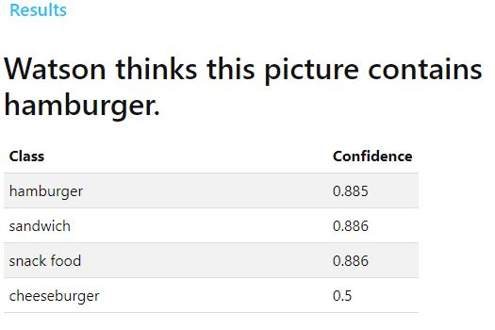

Food Classification node classifies the image that is given by the user.

Next node is Food node is a switch node which will choose the flow based on the image classified by the food classification node.

Not a food is a function node which will display that given image is not a food item. If it is not a food item then announce food node will display the food name with a voice output using text to speech node and audio out node. Text to speech node will convert the given text into a speech/audio and audio out node is used to play the audio.

USDA API url node contains the url of U.S Department of Agriculture which provides the nutrition values from their website.

Http request node is used to give a connection between USDA website and our dashboard for receiving data.

Build Nutrition table node take the received data from the website and using Nutrition table template node we will be display the data to the user.

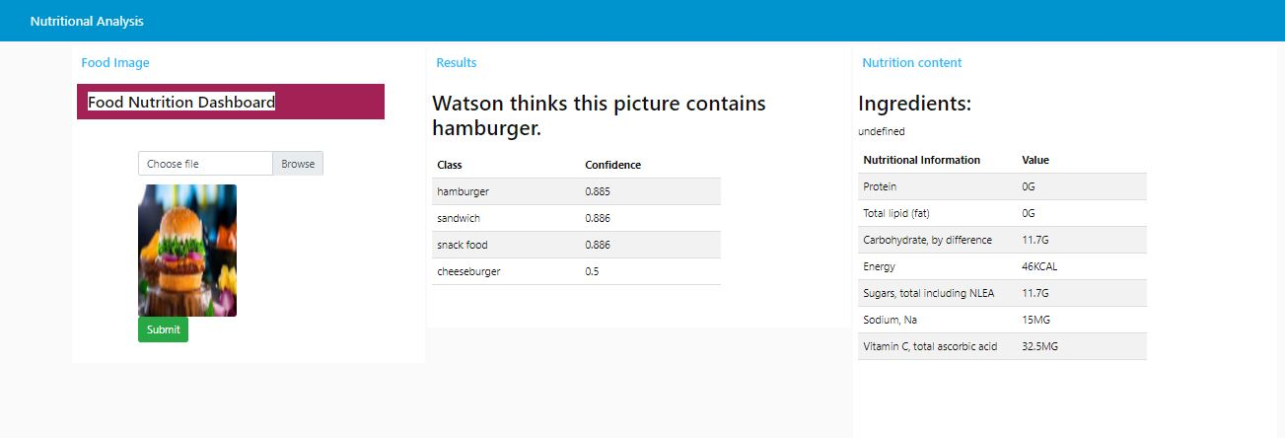

# 6.RESULT:

# **Nutrition Image Analysis Dashboard for an Image:**

# When we give an image as input it will classify the image as food or non-food. If it is a food item, it identifies and reads out the name of the food item with its calculated Nutrition Content.

# **Nutrition Image Analysis Dashboard for a Non-Food Image:**

When we give an image which contains non-food, it identifies the image and reads out that the image contains a non-food item and also asks us to provide a valid food image.

# 7.ADVANTAGES & DISADVANTAGES:

## Advantages:

1. Every individual can check the nutrition content of food.
2. It is time saving process to check nutrition content of a food item.
3. Keeps recipes organized.

## Disadvantages:

1. We can only get the result of one food item at a time.
2. It cannot recognize local food items.

# **8**.APPLICATIONS:

This web application can be used by the Gym Trainers, Nutritionist, Doctors, Dietician, Pregnant Women, etc.

# 9.CONCLUSION:

We have created a nutrition analysis dashboard which can recognize the image and classify it as food or non- food and can give the nutrition contents if it is a food item or it will ask you to provide an appropriate image.

# 10.BIBLIOGRAPHY:

These websites are used in the project

IBM Cloud -- https://cloud.ibm.com/login

U.S Department of Agriculture website -- https://fdc.nal.usda.gov/index.html

## 